**Module 5**

**Assignment 1**

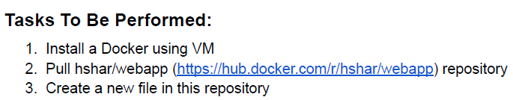

1. Create a VM, connect to the VM and install docker.io – sudo apt install docker.io -y

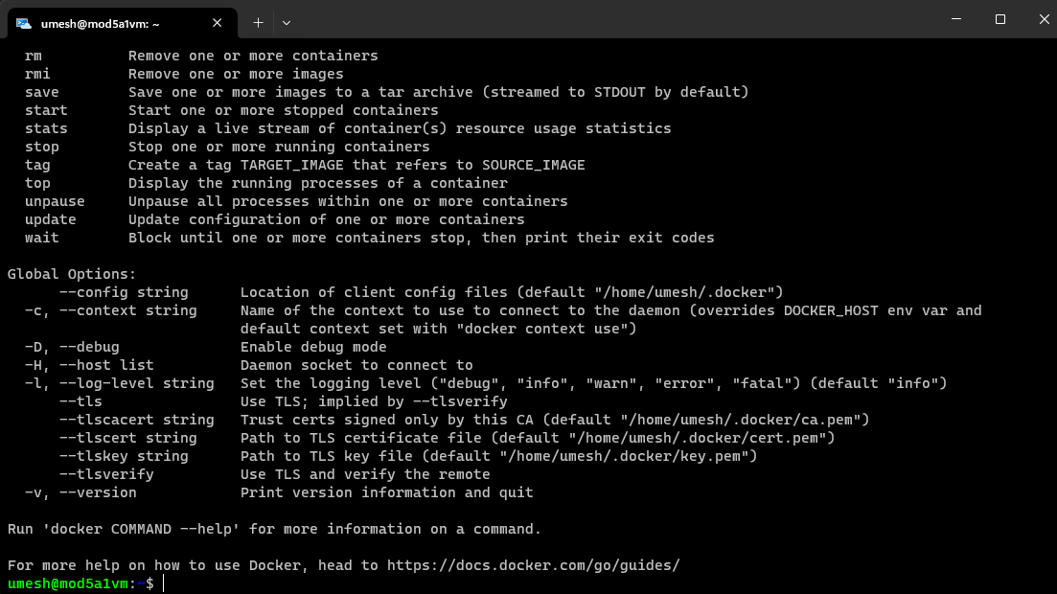

1. Pull the docker image by : sudo docker pull hshar/webapp:latest

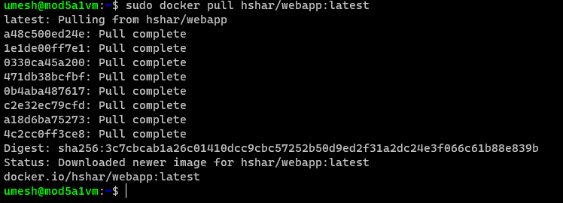

1. Create a new file inside the repo.

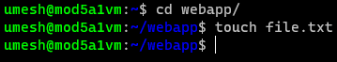

**Assignment 2**

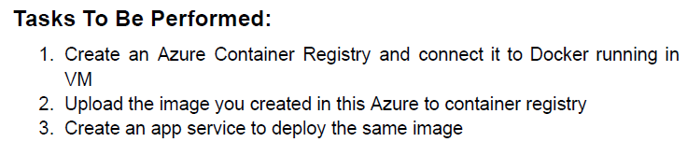

1. Create a Container Registry.

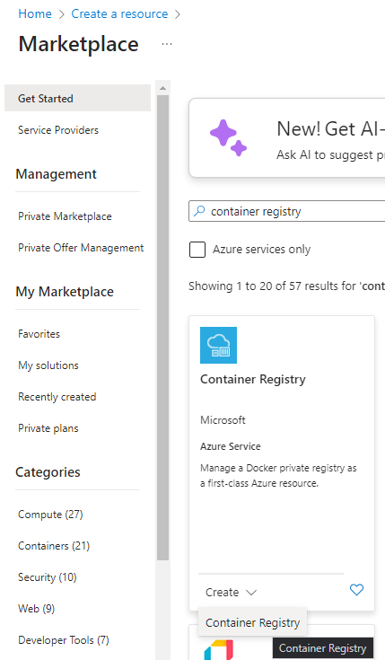

1. Get the ACR Credentials.
2. Connect Docker to ACR : docker login <acr-login-server> -u <acr-username> -p <acr-password>

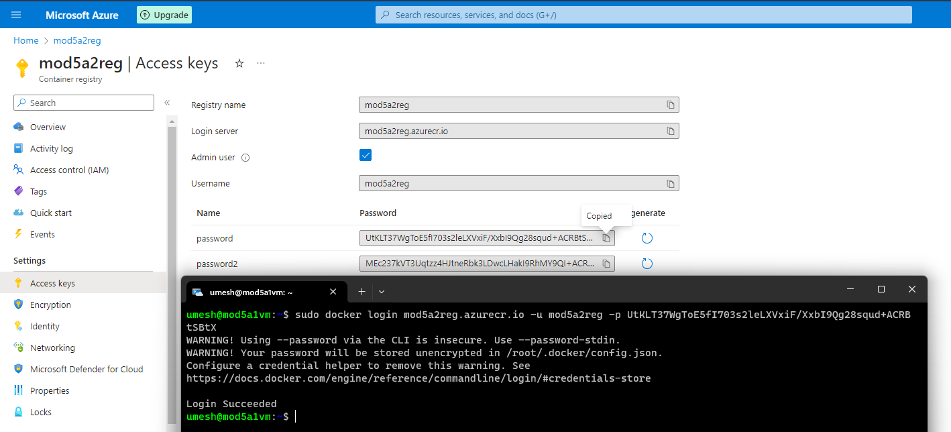

1. Tag and push the docker image : sudo docker tag hshar/webapp mod5a2reg.azurecr.io/mod5a2:latest and sudo docker push mod5a2reg.azurecr.io/mod5a2:latest

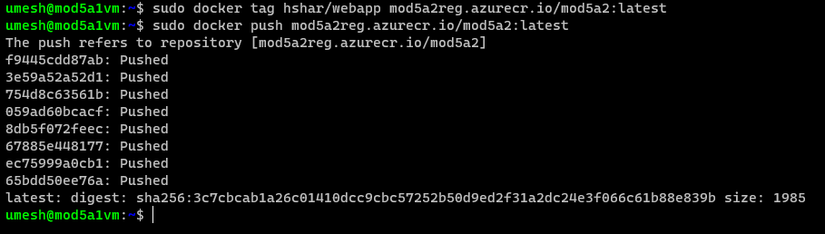

1. Create a Web App

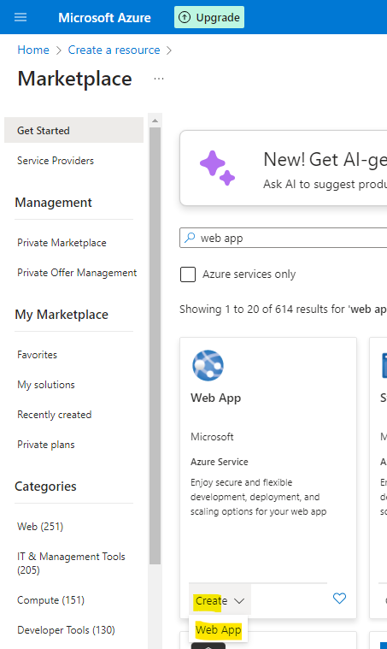

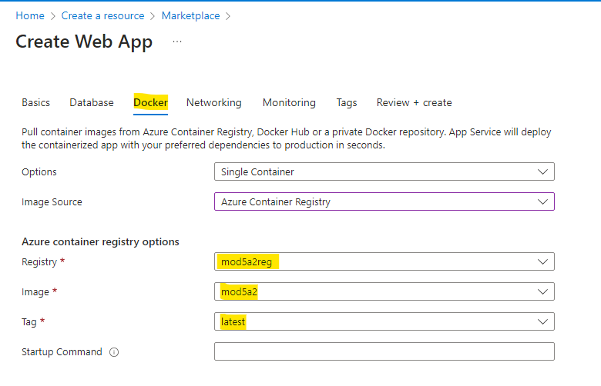

1. Web App has been successfully deployed from the docker image pulled earlier.

